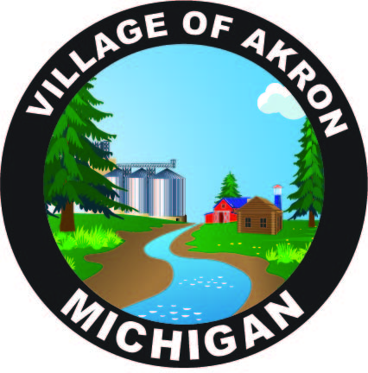

VILLAGE OF AKRON

SPECIAL COUNCIL MEETING

AGENDA

DECEMBER 28, 2024

SPECIAL MEETING

1. PLEDGE OF ALLEGIANCE

2. ROLL CALLL

3. FINANCIAL TRANSFER

4. ARPA

5. PUBLIC COMMENT

ADJOURNMENT