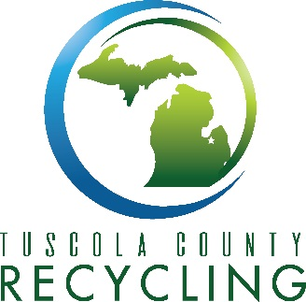

TUSCOLA COUNTY NOTICE

On August 8, 2024 TUSCOLA COUNTY HAS FILED ITS

NOTICE OF INTENT TO PREPARE THE MATERIALS MANAGEMENT PLAN

AND HAS BECOME THE COUNTY APPROVAL AGENCY

as required per Part 115, Solid Waste Management, of the Natural Resources and Environmental Protection Act,1994 PA 451, as amended.

Tuscola County intends to complete the MMP development as a MULTICOUNTY plan with: Huron, Lapeer and Sanilac Counties. Please note that all materials management planning committee meetings are open to the public and notices of these meetings shall be found on the County website [www.tuscolacounty.org](http://www.tuscolacounty.org) or copies can be picked up at Tuscola County Recycling at 987 Ellington St Caro, MI 48723 in addition each municipality will receive notice and will have the meeting notices available as well.

Direct questions to

Mike Miller

Tuscola County Recycling

989-672-1673