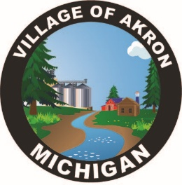
VILLAGE OF AKRON
SPECIAL COUNCIL MEETING
CLERK INTERVIEWS
FEBRUARY 13, 2025

The Akron Village Council meeting was called to order at 5:56 p.m. followed by the Pledge of Allegiance and roll call.
Council Members Present: R. Huizar, M. Strasz, T. Nusz, D. Meyer
Employees Present: M. Wilinski

The Village of Akron council interviewed three potential candidates for the clerk’s position. All candidates answered questions posed to them from the council. The candidates were notified that a decision will be made by at the next council meeting.

Motion by T. Nusz to adjourn at 7:17 p.m. M. Strasz supported the motion. Motion carried.

Respectfully submitted,

Monica Wilinski
Akron Village Clerk

