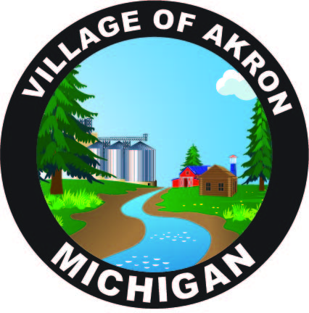

VILLAGE OF AKRON

SPECIAL COUNCIL MEETING

DEPARTMENT OF PUBLIC WORKS INTERVIEWS

JANUARY 20, 2025

The Akron Village Council meeting was called to order at 5:18 p.m. followed by the Pledge of Allegiance and roll call.

**Council Members Present:** R. Huizar, M. Strasz, T. Nusz, D. Meyer

**Employees Present:** M. Wilinski

There were three candidates to interview for the Department of Public Works position. All three potential employees answered questions from the council members in a professional and appropriate manner.

Council discussed potential employees answers and qualifications. A decision is pending.

**Public Comment:** None.

Motion by T. Nusz to adjourn at 6:29 p.m. D. Meyer supported the motion. Motion carried.

Respectfully submitted,

Monica Wilinski

Akron Village Clerk