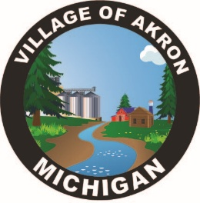
VILLAGE OF AKRON
SPECIAL COUNCIL MEETING AGENDA
BUDGET, POLICE DEPARTMENT & ATTORNEY
CONSULTATION INFORMATION
FEBRUARY 25, 2025

1. CALL TO ORDER
2. PLEDGE OF ALLEGIANCE
3. ROLL CALL
4. POLICE DEPARTMENT EMPLOYEES
5. ATTORNEY CONSULTATION INFORMATION
6. BUDGET
7. PUBLIC COMMENT
ADJOURNMENT

