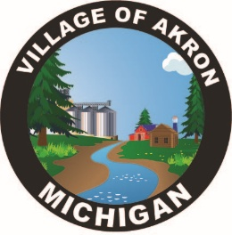
VILLAGE OF AKRON
SPECIAL COUNCIL AGENDA
POLICE INTERVIEWS
FEBRUARY 4, 2025

- PLEDGE OF ALLEGIANCE
- ROLL CALL
- INTERVIEW
- PUBLIC COMMENT
- DISCUSSION

ADJOURNMENT

