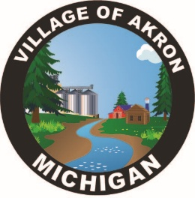
VILLAGE OF AKRON
SPECIAL COUNCIL MEETING
CLERK INTERVIEWS
FEBRUARY 13, 2025

- PLEDGE OF ALLEGIANCE
- ROLL CALL
- INTERVIEWS
- PUBLIC COMMENT
- DISCUSSION

ADJOURNMENT

