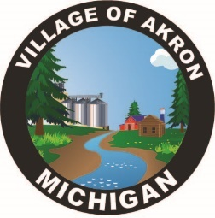

VILLAGE OF AKRON

COUNCIL AGENDA

SEPTEMBER 17, 2024

REGULAR MEETING

1. PLEDGE OF ALLEGIANCE

2. ROLL CALL

3. AKRON COUNCIL MINUTES APPROVAL - AUGUST 20, 2024

4. AKRON SPECIAL COUNCIL MINUTES APPROVAL - SEPTEMBER 3, 2024

5. PUBLIC COMMENT

6. BILLS

7. PRESIDENT'S REPORT

A. PUBLIC WORKS REPORT

1. MAX CLASSES

B. FIRE REPORT

C. TREASURER'S REPORT

D. POLICE REPORT

1. POLICE ACTIVITY

E. CLERK REPORT

1. PRADO READY TO SERVE BILL

2. MI ASSOC. OF MUNICIPAL CLERKS

3. RES. 08-2024 SHANNON PARTIAL TERMINATION

4. MONTHLY EQUIPMENT USAGE FORM APPROVAL

5. INFORMATION CHANGE FORM APPROVAL

6. MAX REIMBURSEMENT FOR BOOK

7. NON-SUFFICIENT FUNDS TAX CHECK FROM SHANNON FARMS

8. SAFETY DEPOSIT BOX INVENTORY

9. SET UP OF NEW COMPUTER

10. DOG COMPLAINT 3533 N. MAIN ST.

11. ORDINANCES

8. OLD BUSINESS

A. INSPECTOR FOR 3617 N. MAIN ST.

B. BEAN CLEAN UP

C. CAMERA'S/DVR

D. COGITATE/QUICKBOOKS

E. GARRISON/MORSE TAX & W/S/T/ BILL

9. NEW BUSINESS

A. RISERS FOR PARKING LOT

B. FIRE HYDRANT REPAIR

10. PUBLIC COMMENT

ADJOURNMENT

Next Council Meeting October 15, 2024