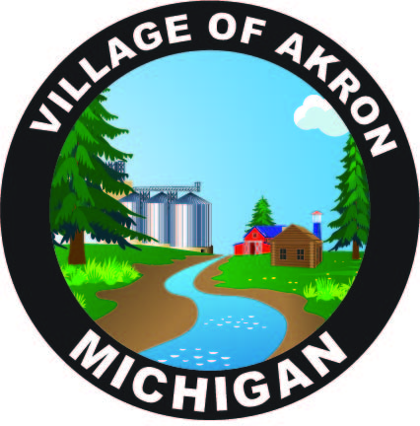

VILLAGE OF AKRON

COUNCIL AGENDA

DECEMBER 17,2024

REGULAR MEETING

1. PLEDGE OF ALLEGIANCE

2. ROLL CALL

3. AKRON COUNCIL MINUTES APPROVAL - NOVEMBER 19, 2024

4. AKRON SPECIAL COUNCIL MINUTES APPROVAL - DECEMBER 5, 2024

5. PUBLIC COMMENT

6. BILLS & OBLIGATIONS APPROVAL

7. PRESIDENT'S REPORT

FILL COUNCIL SEAT

A. PUBLIC WORKS REPORT

1. ALARM CALL LIST APPROVAL

B. FIRE REPORT

C. TREASURER'S REPORT

D. POLICE REPORT

1. LEIN CERTIFIED I.T. PERSON

E. CLERK'S REPORT

1. CLOSING TEAM ONE CREDIT CARDS

2. MOVE TEAM ONE STATEMENTS TO E-STATEMENTS

3. MML LIABILITY & PROPERTY POOL RENEWAL

4. GENERATOR MAINTENANCE

5. AIR ADVANTAGE PHONE QUOTE

6. LAWYER INQUIRIES

7. MINIMUM WAGE INCREASE

8. OLD BUSINESS

9. NEW BUSINESS

A. W/S/T 10% PENALTY RATE

B. APPROVAL OF 2025 COUNCIL MEETING SCHEDULE

C. MI FUNDING HUB

10. PUBLIC COMMENT

ADJOURNMENT

NEXT COUNCIL MEETING JANUARY 21, 2025