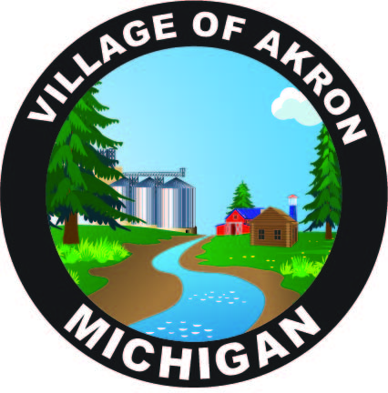

VILLAGE OF AKRON

COUNCIL AGENDA

NOVEMBER 19, 2024

REGULAR MEETING

1. PLEDGE OF ALLEGIANCE

2. ROLL CALL

3. AKRON SPECIAL COUNCIL MINUTES APPROVAL - SEPTEMBER 26, 2024

4. AKRON COUNCIL MINUTES APPROVAL - OCTOBER 15, 2024

5. AKRON SPECIAL EMPLOYEE MEETING MINUTES APPROVAL -

OCTOBER 18, 2024

6. PUBLIC COMMENT

7. BILLS & OBLIGATIONS APPROVAL

A. U.S.A. BLUEBOOK

B. DIETZEL ELECTRIC GENERATOR MAINTENANCE CONTRACT

8. PRESIDENT'S REPORT

A. PUBLIC WORKS REPORT

B. FIRE REPORT

C. TREASURER'S REPORT

1. DPW PHONE PLAN QUOTE

2. OFFICE CELL PHONE PLAN QUOTE

D. POLICE REPORT

1. POLICE ACTIVITY REPORT

2. LISA HILL

E. CLERK'S REPORT

1. MML LIABILITY & PROPERTY POOL RENEWAL

2. A.C.A. EMPLOYMENT HANDOUT

3. CUSTODIAN PAY INCREASE

4. VASSAR ZONING ADMINISTRATOR LETTER

5. MAY - OCTOBER FINANCIAL STATEMENTS

6. OCTOBER BANK RECONCILIATION

7. MAX'S TIMESHEETS & TIMECARDS

9. OLD BUSINESS

A. INSPECTOR FOR 3617 N. MAIN ST.

B. GARRISON/HILL/MICHIGAN BEAN W/S/T BILLS

C. HYDRANTS

D. CAMERAS

10. NEW BUSINESS

A. CUSTODIAN PAY RAISE

B. PAINTING & WALL REPAIR

11. PUBLIC COMMENT

ADJOURNMENT

NEXT COUNCIL MEETING DECEMBER 17, 2024