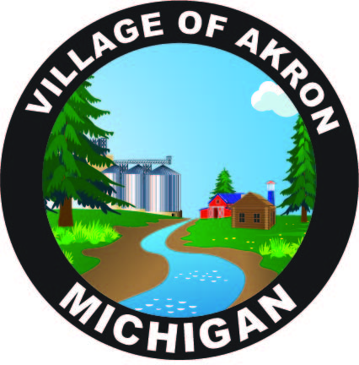

VILLAGE OF AKRON

COUNCIL AGENDA

OCTOBER 15, 2024

REGULAR MEETING

1. PLEDGE OF ALLEGIANCE

2. ROLL CALL

3. AKRON COUNCIL MINUTES APPROVAL - SEPTEMBER 17, 2024

4. AKRON SPECIAL COUNCIL MINUTES APPROVAL -

SEPTEMBER 26, 2024

5. PUBLIC COMMENT

6. BILLS & OBLIGATIONS APPROVAL

7. PRESIDENT'S REPORT

A. PUBLIC WORKS REPORT

1. WELDING SUPPLIES

2. WEED WHACKER REPAIR

3. MOWER TUNE-UP

4. SCREW ASSORTMENT

5. SHUTTING DOWN PARK

6. REMOVING PARK DUMPSTER

B. FIRE REPORT

C. TREASURER'S REPORT

D. POLICE REPORT

1. MCOLES ADVISORY STANDARDS

2. GENERIC EMAIL FOR DEPARTMENT

3. POLICE ACTIVITY REPORT

E. CLERK'S REPORT

1. RESOLUTION FOR DESIGNATION OF STREET ADMINISTRATOR

2. NIETZKE & FAUPEL ENGAGEMENT LETTER

3. END OF YEAR FINANCIAL STATEMENT

4. APRIL FINANCIAL STATEMENT

5. MML LIABILITY & PROPERTY POOL RENEWAL

6. WATER HANG TAG & SHUT OFF PROCEDURE

7. POLICE PROTECTION AGREEMENT

8. OLD BUSINESS

A. INSPECTOR FOR 3617 N. MAIN ST.

B. GARRISON TAX & W/S/T/ BILLS

C. EQUIPMENT RENTAL

9. NEW BUSINESS

A. TRICK OR TREAT HOURS

B. NO PARKING SIGNS FOR EMERY ST.

10. PUBLIC COMMENT

ADJOURNMENT

NEXT COUNCIL MEETING NOVEMBER 19, 2024