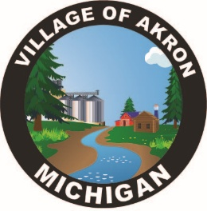
VILLAGE OF AKRON
COUNCIL AGENDA
FEBRUARY 18, 2025

REGULAR MEETING
1. CALL TO ORDER
2. PLEDGE OF ALLEGIANCE
3. ROLL CALL
4. AKRON COUNCIL MINUTES APPROVAL - JANUARY 21, 2025
5. AKRON SPECIAL COUNCIL MINUTES APPROVAL - FEBRUARY 4, 2025
6. AKRON SPECIAL COUNCIL MINUTES APPROVAL - FEBRUARY 6, 2025
7. AKRON SPECIAL COUNCIL MINUTES APPROVAL - FEBRUARY 13, 2025
8. PUBLIC COMMENT
A. ALVIN VOLLMAR - ORDINANCE ON COMMERCIAL PROPERTY
9. BILLS & OBLIGATIONS APPROVAL
10. GFL WASTE DISPOSAL PRESENTATION
11. PRESIDENT’S REPORT
FILL CLERK’S POSITION
SHANE’S TRAINING
A. PUBLIC WORKS REPORT
B. FIRE REPORT
1. PAGER APPROVAL
C. TREASURER’S REPORT
D. POLICE REPORT
1. CITY POLICE OFFERINGS

E. CLERK’S REPORT
1. EMTERRA WASTE DISPOSAL QUOTE
2. MML UNEMPLOYMENT OVERPAYMENT
3. DECEMBER 2024 FINANCIAL REPORT
4. D. GOODCHILD RETURNED CERTIFIED LETTER
5. EMAIL W/S/T BILLS
6. 4263 CENTER ROAD SNOWPLOW COMPLAINT
7. MINIMUM WAGE INCREASE
12. OLD BUSINESS
13. NEW BUSINESS
14. PUBLIC COMMENT

ADJOURNMENT

NEXT COUNCIL MEETING MARCH 18, 2025

