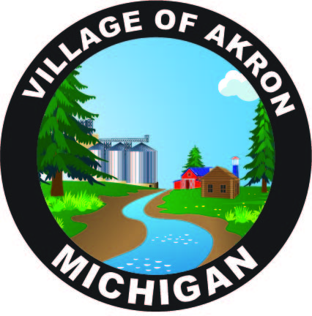

VILLAGE OF AKRON

COUNCIL AGENDA

JANUARY 21, 2025

REGULAR MEETING

1. PLEDGE OF ALLEGIANCE

2. ROLL CALL

3. AKRON COUNCIL MINUTES APPROVAL - DECEMBER 17, 2024

4. AKRON COUNCIL MINUTES APPROVAL - DECEMBER 17, 2024 - CLOSED SESSION

5. AKRON COUNCIL MINUTES APPROVAL - DECEMBER 23, 2024 - BUDGET MEETING

6. AKRON COUNCIL MINUTES APPROVAL - DECEMBER 28, 2024 - ARPA/FINANCIAL TRANSFER

7. PUBLIC COMMENT

8. BILLS & OBLIGATIONS APPROVAL

9. PRESIDENT'S REPORT

HIRING DPW SUPERVISOR

A. PUBLIC WORKS REPORT

1. DESIGNATION OF STREET ADMINISTRATOR

B. FIRE REPORT

C. TREASURER'S REPORT

D. POLICE REPORT

1. POLICE ACTIVITY

2. EMPLOYEE PHYSICALS

E. CLERK'S REPORT

1. POSTCARD STAMPS

2. ABADATA - ACH/CREDIT CARD

3. FORM APPROVALS

4. SECURITY AWARENESS TRAINING

10. OLD BUSINESS

11. NEW BUSINESS

A. ALVIN VOLLMAR - ORDINANCE ON COMMERCIAL PROPERTY

12. PUBLIC COMMENT

ADJOURNMENT

NEXT COUNCIL MEETING FEBRUARY 18, 2025